Windows Digital Forensics Examination Report

1. Case Information
Case ID: IT2564-242100Q
Student Name: Fong Jia Jun
Number of Hours Used in Examination: 12 hours

2. Objective of Examination
The objective of this forensic examination is to analyze a Windows desktop forensic image using the Autopsy forensic tool to identify evidence for resource misuse and unauthorized data exfiltration via removable media and cloud storage services.
3. Evidence Description
Item | Description
Evidence Name | PA.E01
Evidence Type | Windows Desktop Disk Image
Format | E01
Analysis Tools | Autopsy, FTK Imager, RegRipper 3.0, Windows Event Viewer, Timeline Analysis, CVS/Excel MS
Source | Windows Local Drive
Hash Verification | Verified by Autopsy, MD5 hash is 38714652286392376913508624108632
The image was added to Autopsy as a data source, and hash verification completed successfully with no errors reported.

4. Forensic Tool and Ingest Modules Used
The following Autopsy ingest modules were enabled:
- Data Carving: Specifically used to recover deleted files from unallocated space, which successfully identified Todo_exe and PilotshubApp_exe.
- File Type Identification: To detect any extension mismatches
- Recent Activity: To extract Jump Lists, .lnk files, and Registry hives
- Web Artifacts: To recover history from Edge and Chrome
- Keyword Search: To locate “Secret Stuff” and filter dates of deleted items based on time frames.
- Timeline Analysis: Used to Correlate MAC times with logon events
- Windows Event Viewer: Used to view the Logons Events and filter based on Account and EventID (4624, 4625, 4634, 4647, 4616)
- RegRipper 3.0: Used to rip the Registry hives (SAM, SYSTEM, and NTUSER.DAT) from exported files exported from Autopsy and return the result in a readable txt format
- FTK Imager Exterro: Used for verification of hash values ensuring that no changes were made when file was turned into an image file. Also used for browsing through the file system at a lower level than a standard OS, allowing me to see $Recycle.Bin and System Volume Information.
- Excel/CSV Viewer: Used to analyze and filter the exported results of “Suspicious Items,” “USB Devices,” and any “Deleted Files”

5. Examination Methodology (Using Autopsy)
The examination was conducted using the following steps:
- Creation of a new case in Autopsy
- Addition of the E01 image as a data source
- Execution of selected ingest modules
- Review of artefacts using Autopsy views
- Timeline analysis to correlate events
- Documentation of findings with artefact references

6. Findings (with screenshots of evidence displayed in Autopsy, FTK Imager, RegRipper, …)
6.1 User Accounts
Using Operating System Information and Registry Key artefacts, the following was identified:
Actions Taken:
- Using RegRipper 3.0 and Autopsu’s OS accounts artifact to parse both SAM and SYSTEM registry hives.
- Locate the SAM and SYSTEM files within the %SYSTEMROOT%/System32/Config/
Directory of the PA.E01 evidence image.
- With the reference to the %SYSTEMROOT%/System32/Winevt/Logs and finding the security logs (security.evtx), we are able to filter the Logon events via the User and EventID through external viewer (Windows Event Viewer).
- Through the SAM Hive and Windows Event Viewer confirmed:
- SelmaBouvier: Primary active user during the suspected exfiltration window of 13/03/2019 – 19/03/2019.
- Administrator: Identified 13 Login Sessions through ripping the registry hive of SAM; the description mentions used for both local maintenance and remote administration. (Including Type 10, 3, and 7 Logon Events)
With a time period of logs active from:
28/7/2018 8:41:08am – 28/7/2018 4:35:42pm,
29/12/2018 9:06:58am – 29/12/2018 9:08:00am,
16/1/2019 4:12:32am – 16/1/2019 4:17:48am,
13/2/2019 11:07:03am,
26/2/2019 2:16:16am – 26/2/2019 4:43:00am,
13/3/2019 10:03:08am,
21/3/2019 4:57:37am – 21/3/2019 4:57:44am
- User: A legacy account showing an anomaly where logoff preceded logon, attributed to log retention limits rather than clock tampering.
With a time period of:
28/7/2018 9:01:49am – 3:32:33pm
Active period – 28/7/2018 3:31:48pm – 3:32:32pm

SelmaBouvier
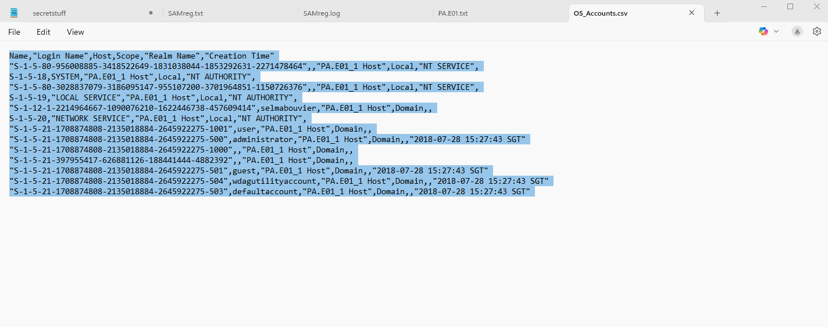
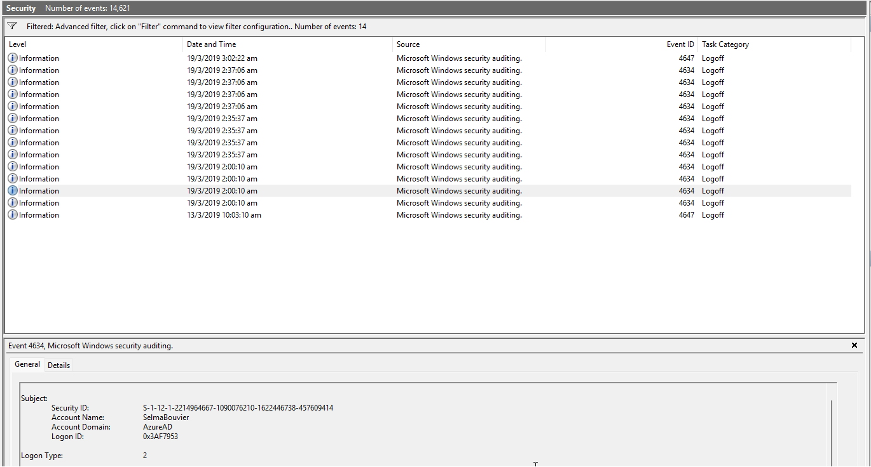

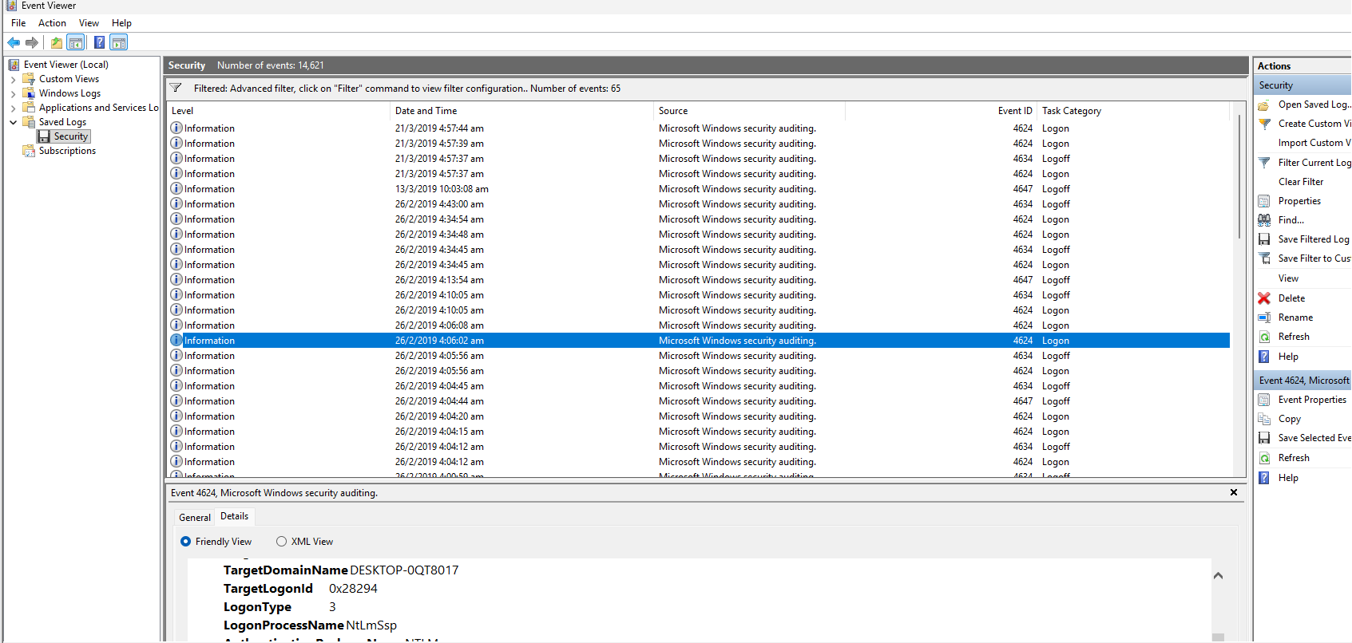
Administrator
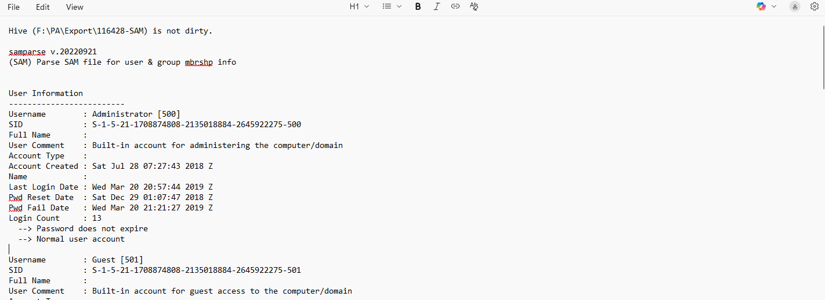

User

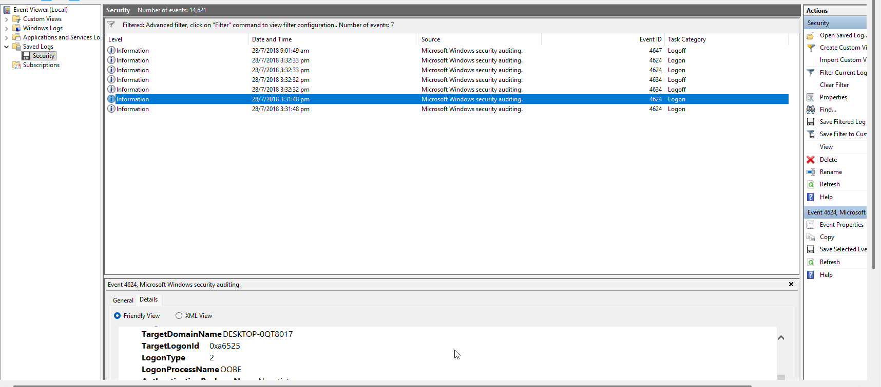

6.2 Program Execution
Evidence of program execution was identified using:
- Prefetch files: Confirmation of the execution of specific applications and used to record the last eight execution timestamps by the user
- Jumplists: Utilized to identify any applications in use and specific items’ metadata accessed through those applications
- Last Visit MRU (MRUList): Analyzation of NTUSER.DAT registry hive to track applications and the directory locations of the files they interacted with
- UserAssist: Identify any GUI-based program execution run counts, and focus time
- User Home Directory: Manual analysis of the user home’s paths (e.g AppData/Local/Temp , Desktop) to find any application remnants and portable binaries
These artefacts indicate execution of common applications such as:
- Web browsers: Microsoft Edge shows signs of downloading resources such as the MEGA-RECOVERYKEY and access SharePoint
- Forensic & Remote Tools: FTK Imager Lite 3.1.1 showed signs of usage found on the Administrator’s desktop (User/Administrator/Desktop). While Teamviewer artifacts were both found and identified within the Administrator and Selmabouvier Temp Directories (AppData/Local/Temp).
- Cloud Syncing Utilities: OneDrive showed active usage through the MAC times of the resources relating to OneDrive (FileSyncClient.dll and CollectSyncLogs.bat).
- Task Management: Usage of file carving in order to recover any execution traces and found Todo_exe and PilotshubApp_exe as results from the action.

Actions Taken:

- Ingest Module Execution: Enabled the Recent Activity and Data Carving (PhotoRec) modules in Autopsy in which recovered deleted executables were automatically organized into the $CarvedFiles directory.
- Registry Analysis: decoded UserAssist keys (ROT-13) and Parsed MRUList entries to establish a history of GUI applications and file interactions within the NTUSER.DAT
- Path Examination: Conduct manual directory research through user Temp and Desktop folders to identify any deletion or downloaded execution application remnants like the FTK Imager and TeamViewer and any installation agents
- Metadata Correlation: Cross-referenced Prefetch last-run times with active user sessions to attribute execution to specific accounts

Time Correlation and results:

- Administrative Maintenance: Identified four Windows Install Agents (.dat) files within the Administrator’s Temp directory. The timestamps which were 26/02/2019 05:25 SGT correlate with the end of one of the following administrator’s session (02:16 – 04:43 SGT), indicating authorized software updates as part of the administrator’s role.
- Remote Tool Usage: TeamViewer artifacts were both identified in Administrator’s and Selmabouvier’s home directories (%HOME%/AppData/Local/Temp). Upon further inspection of the directories, it found in Administrator that an update.exe was deleted within the Temp folder, and a deleted TeamViewer directory was identified in SelmaBouvier’s Temp folder with the folder being completely emptied, suggesting attempts to internally conceal usage of the program
- Forensic Tool Execution: FTK Imager 3.1.1 found in Administrator’s desktop was found to have a modified time that precedes the Creation Time, suggesting that the tool was either copied or moved from another location/external volume.
- Carved Artifacts: Successfully recovered both Todo_exe and PilotshubApp_exe from unallocated spaces found within the Imager. The lack of file system metadata for these executables suggest that they were internally concealing them to hinder any investigation.

Ingest Module Extraction:
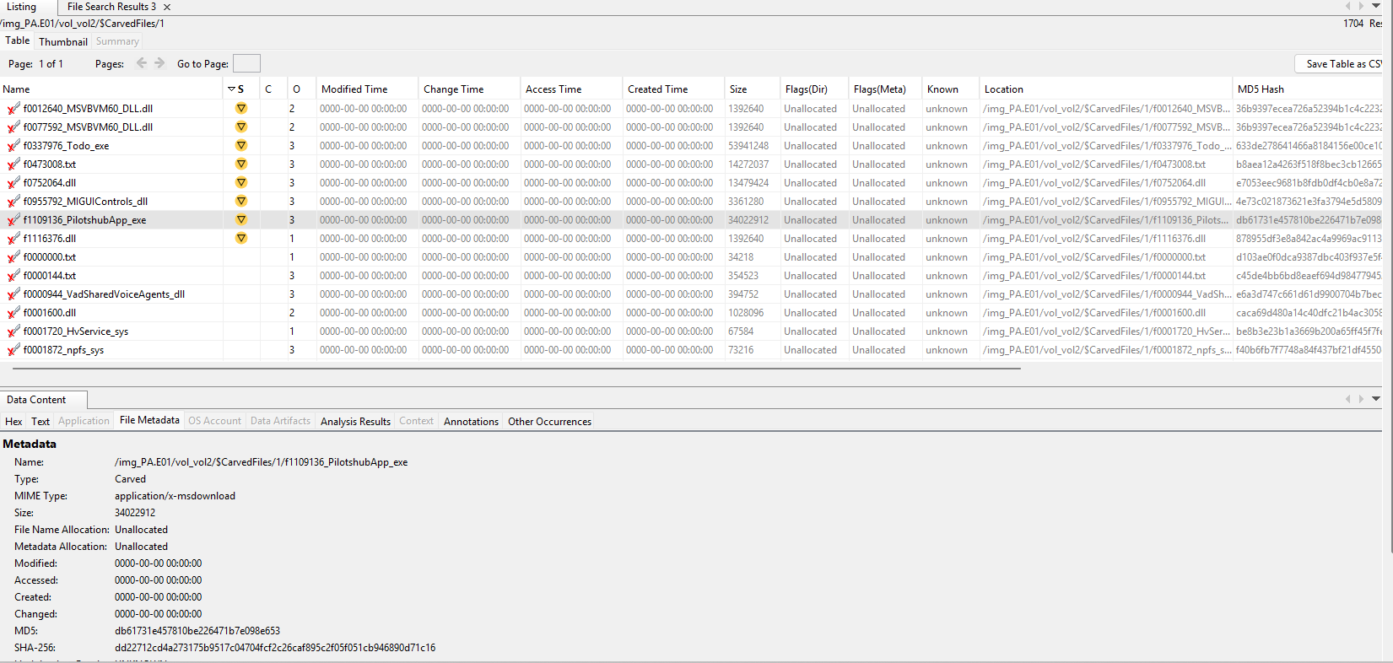

Registry Analysis:
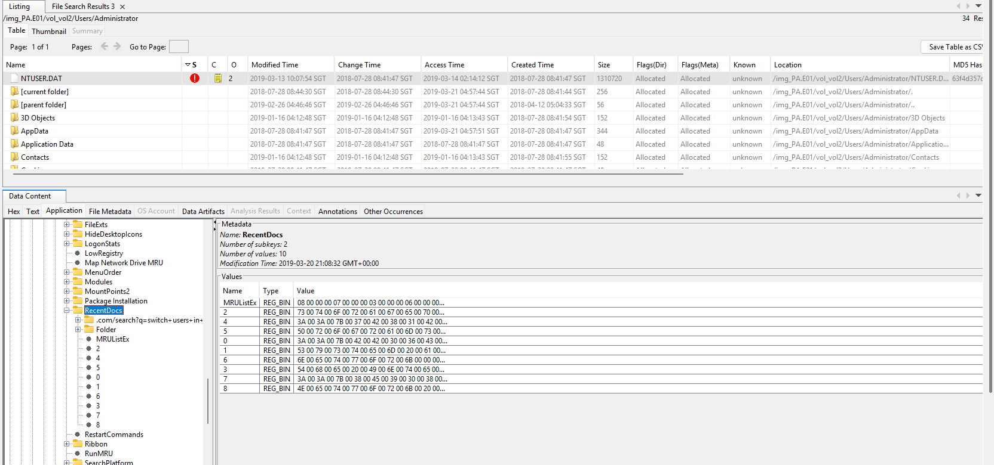
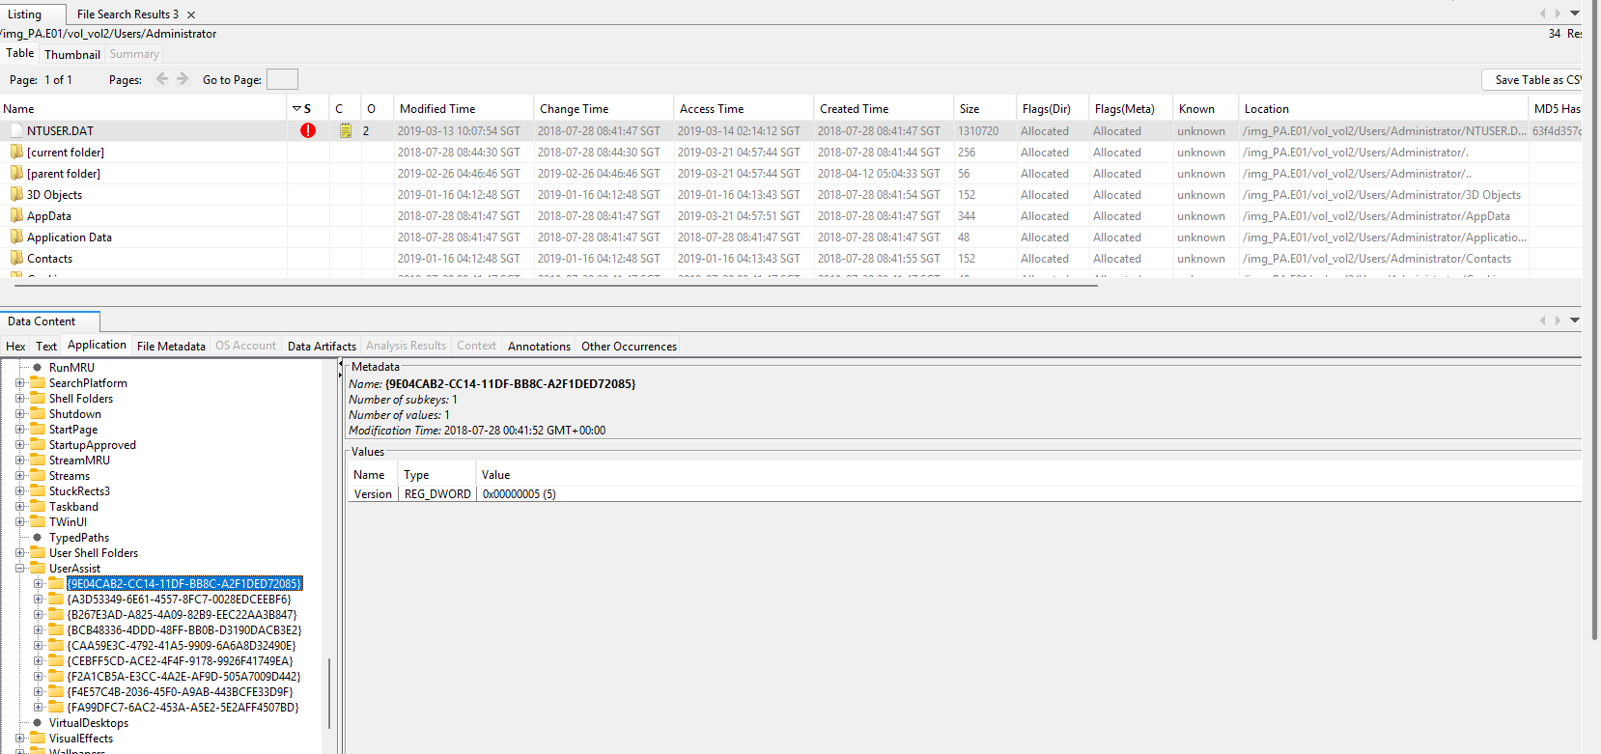
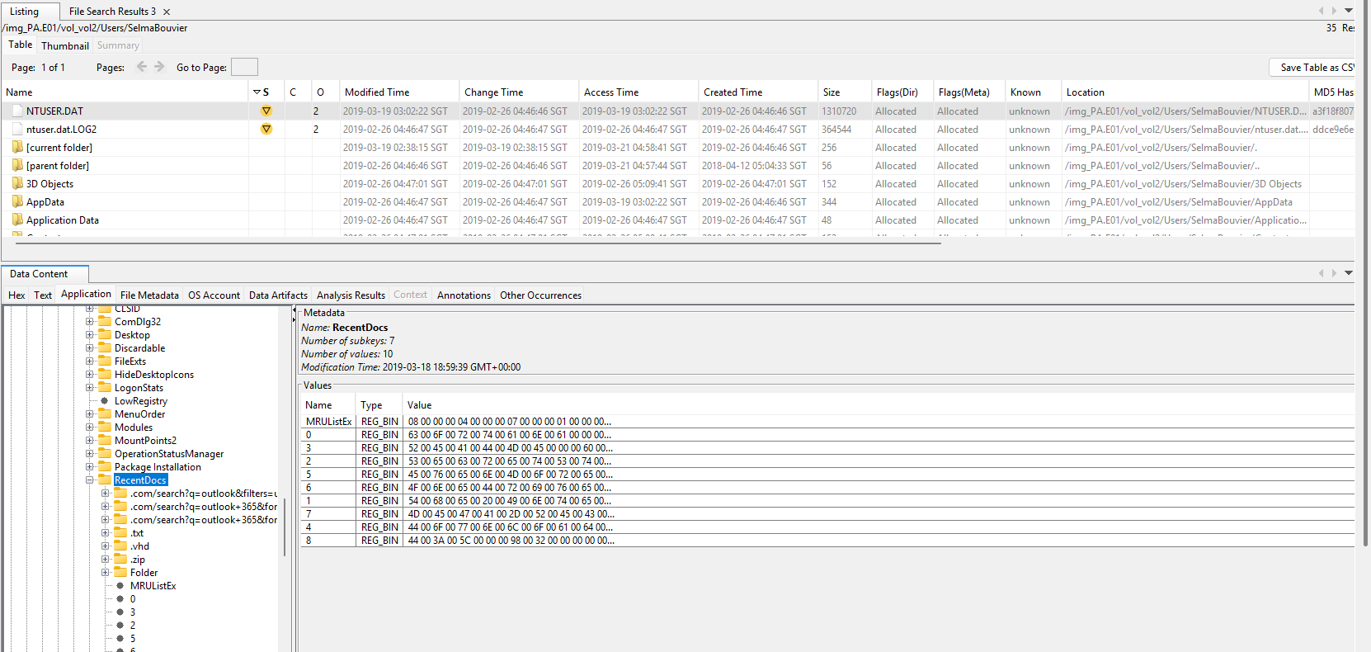
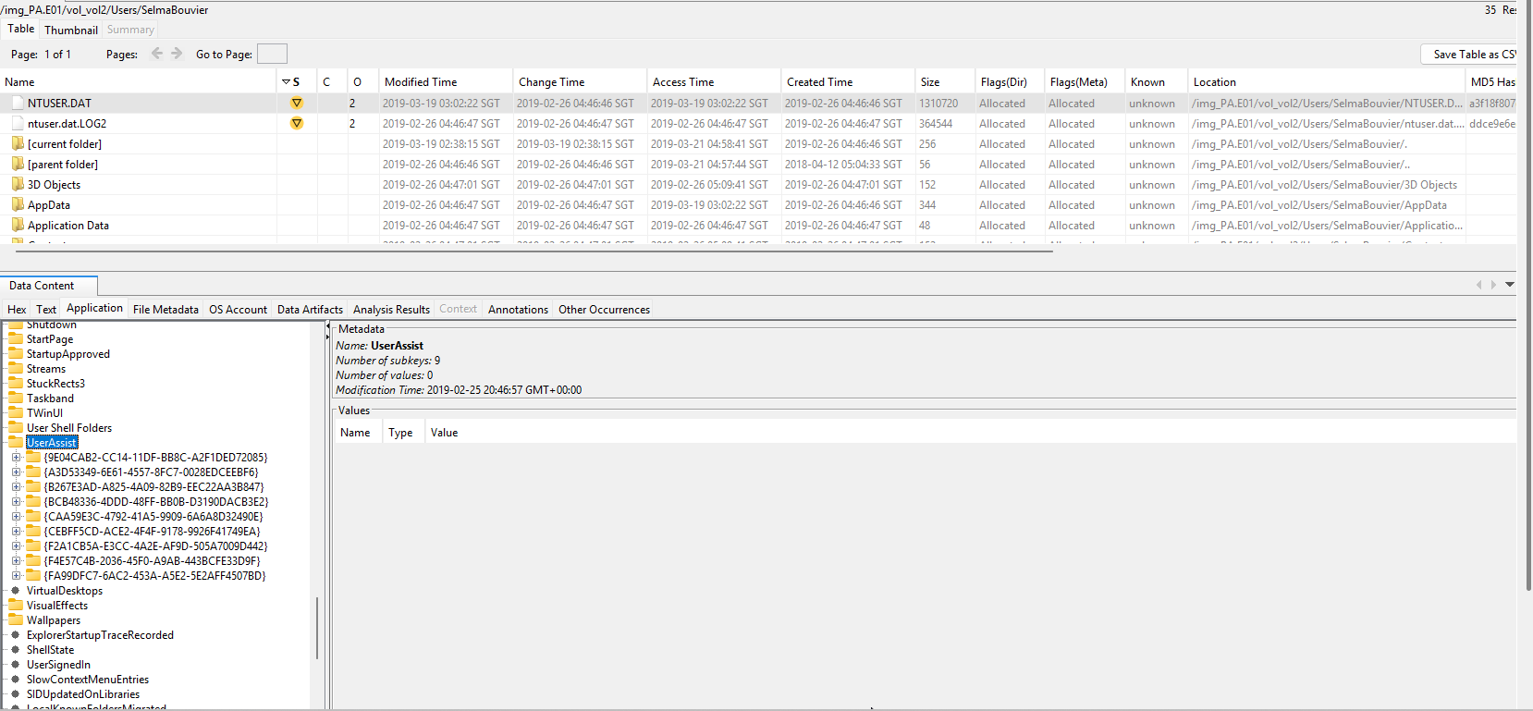

Path Examinations:
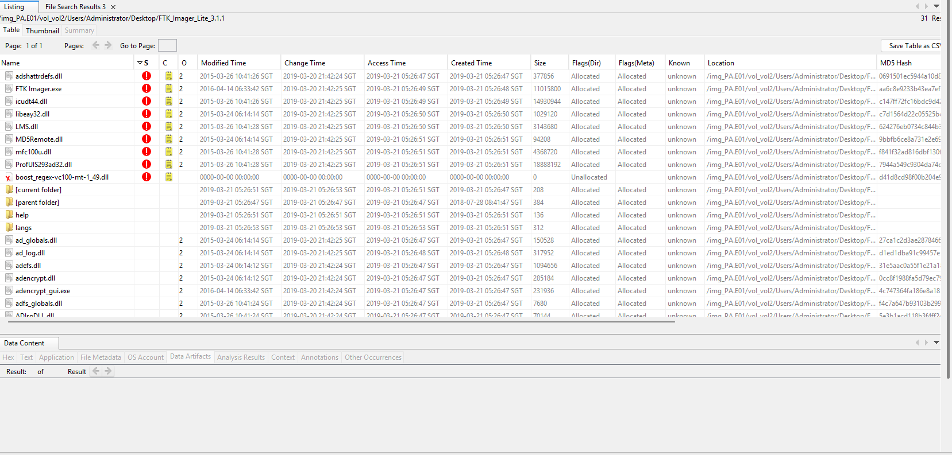
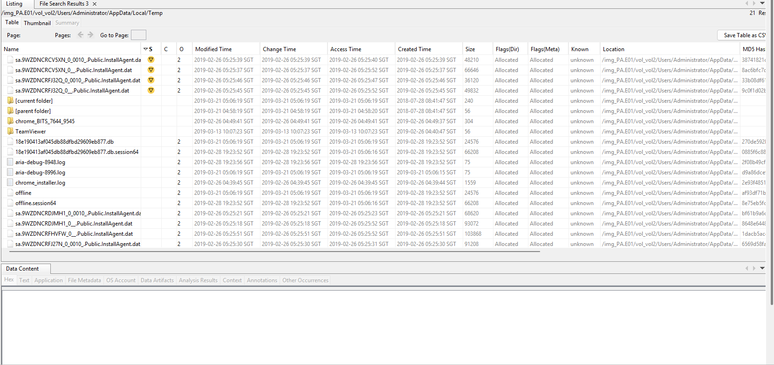
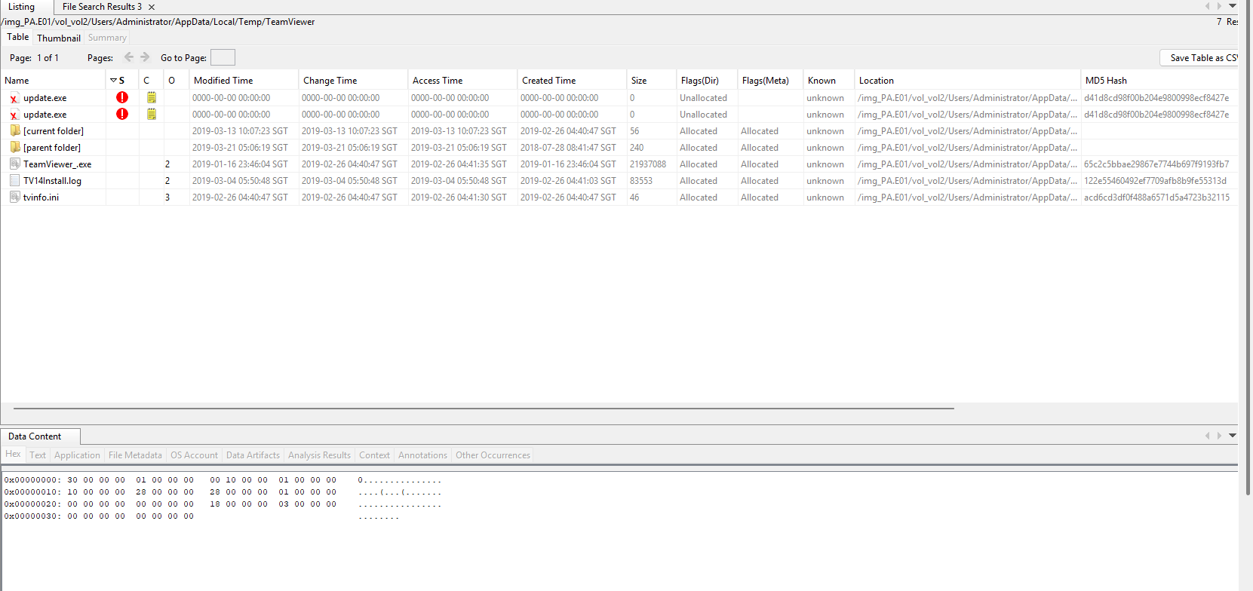
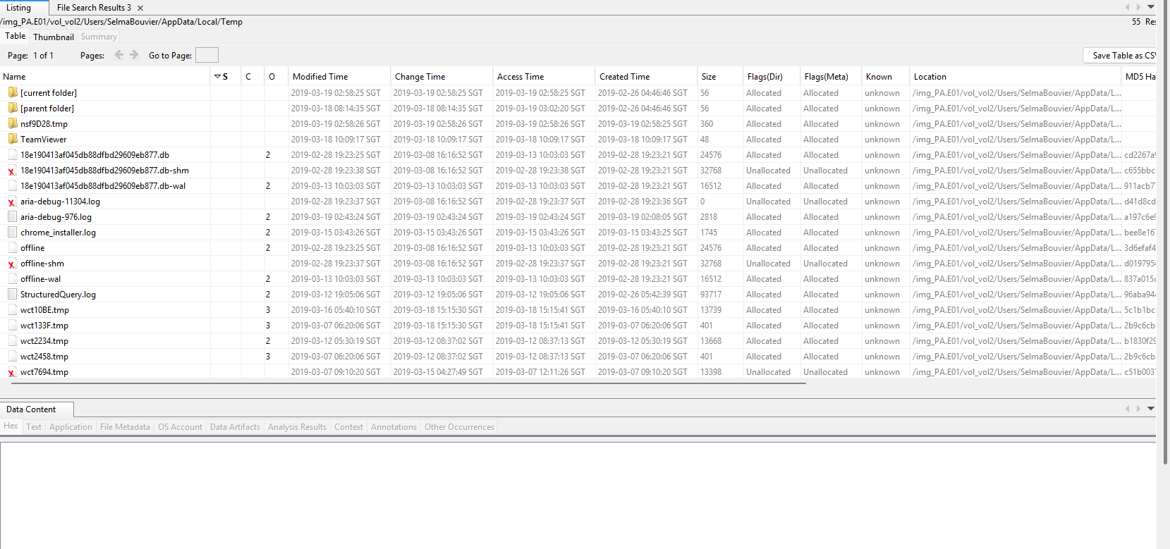
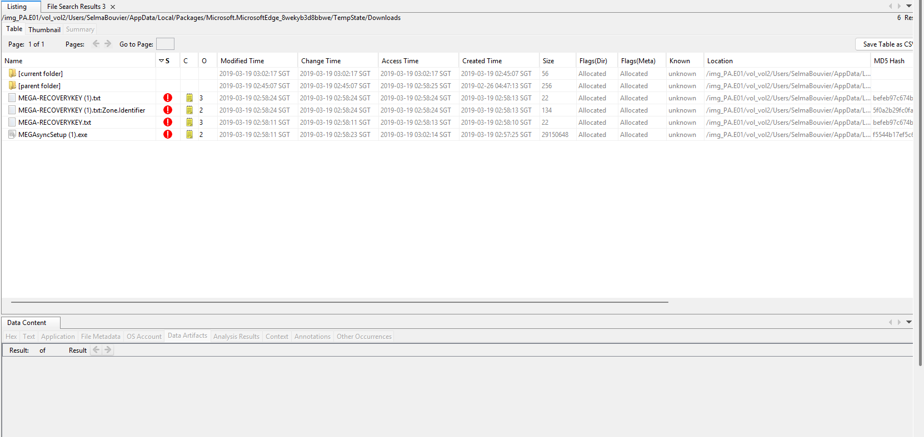

6.3 File and Folder Activity
Using Recent Activity and File System views:
- User documents were accessed and modified
- Deleted files were identified in unallocated space
- Some deleted files were partially recoverable
File metadata such as Created, Modified, and Accessed timestamps were reviewed.

Actions Taken:
- Shortcut Link Analysis: Analyzed the recently accessed files within shortcuts and identified crucial files accessed such as SecretStuff.lnk within SelmaBouvier (/Users/Selmabouvier/AppData/Roaming/Microsoft/Windows/Recent/)
- Container Identification: Following Shortcut links to their original path files in which SecretStuff.lnk traced back to a deleted virtual Hard Disk (SecretStuff.vhd) on the desktop, often used for staging bulk data
- Blueprint Metadata Review: Analyzed at-5000-s1.jpg in the OneDrive/Magnetic4nsics folder in which the Creation timestamp was later than the modified timestamp, proving that the file may have been copied into the One Drive via an external source or location.
- USB Connection Tracking: Identified an Adomax USB with a Serial ID of 42 connecting to the system at 21/03/2019 04:55:32 SGT, which happens to correlate when the forensic tools were being removed
- Extension Mismatch Analysis: In the Analysis results of extension mismatches where there are 174 mismatches detected. While no blueprints were renamed were found (e.g at-5000.jpg), there contained .dat files stored in SelmaBouvier’s Recovery/Active Edge folder being flagged as MS Office MIME types, proving that company documents were accessed via the Edge browser
- MFT Metadata Cross-Check: Performed a bit-level comparison of the blueprints’ $Standard_Information vs. $File_Name attributes. Identified a mismatch within the Created vs. Modified times which can prove there was a Volume Move from the Adomax USB.

Shortcut Files Analysis:
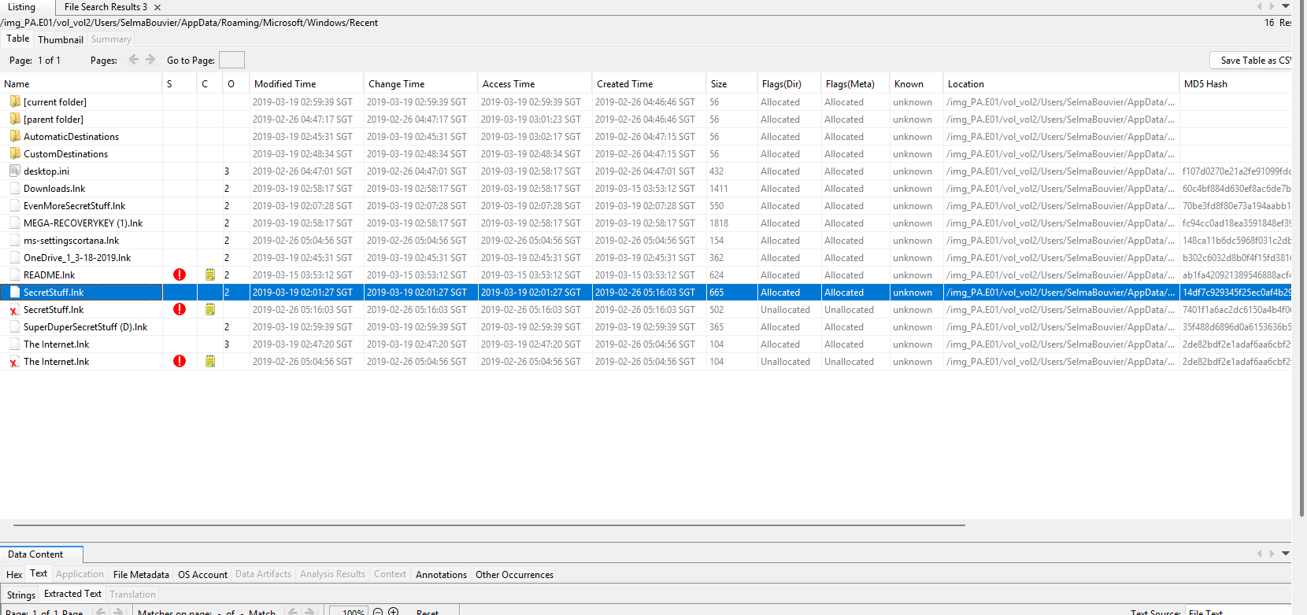

Container Identification:
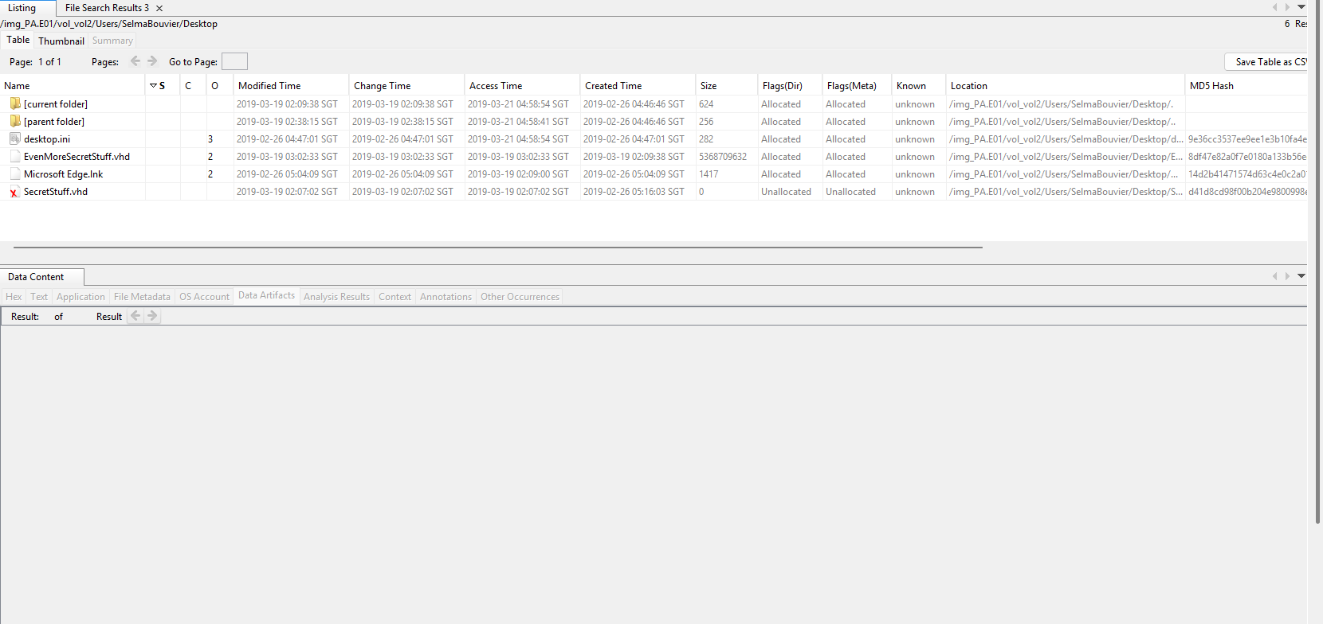

Blueprint Metadata Review:
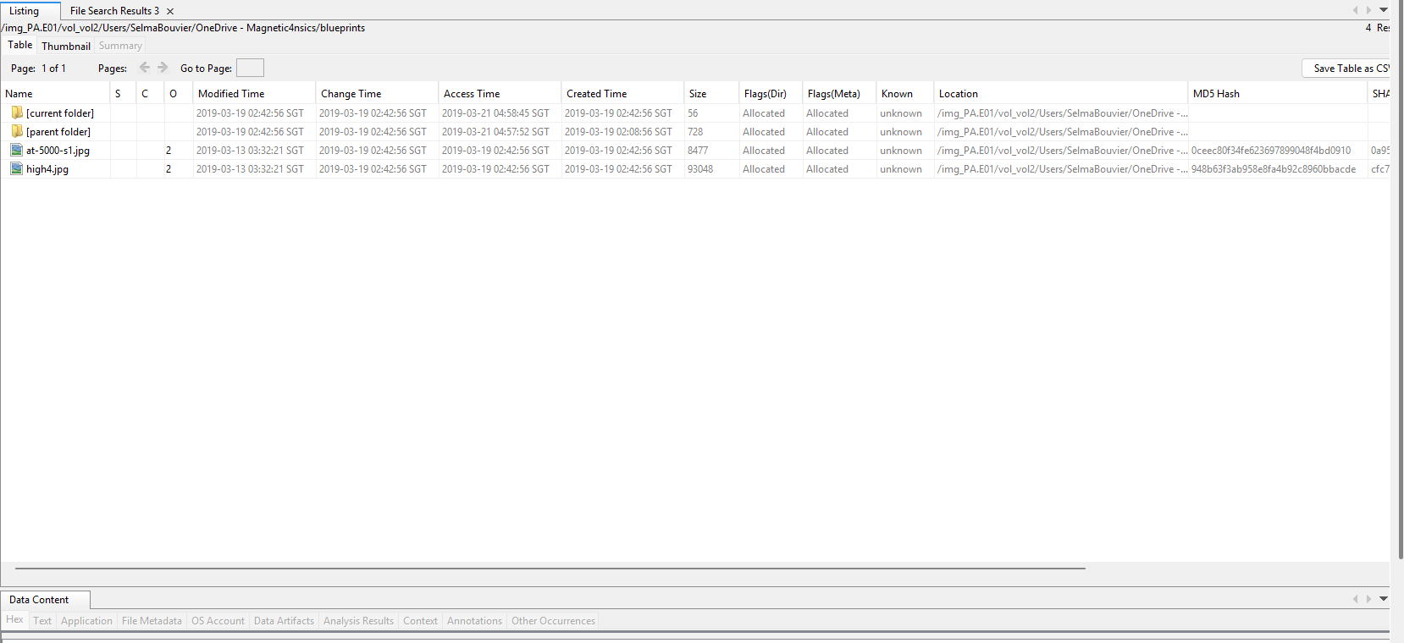

USB Connection:
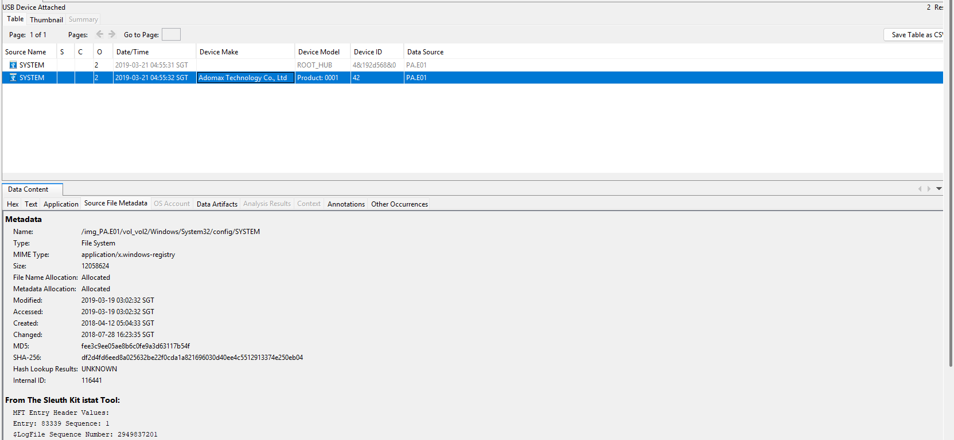

Systematic Deletion:


Extension Mismatches:
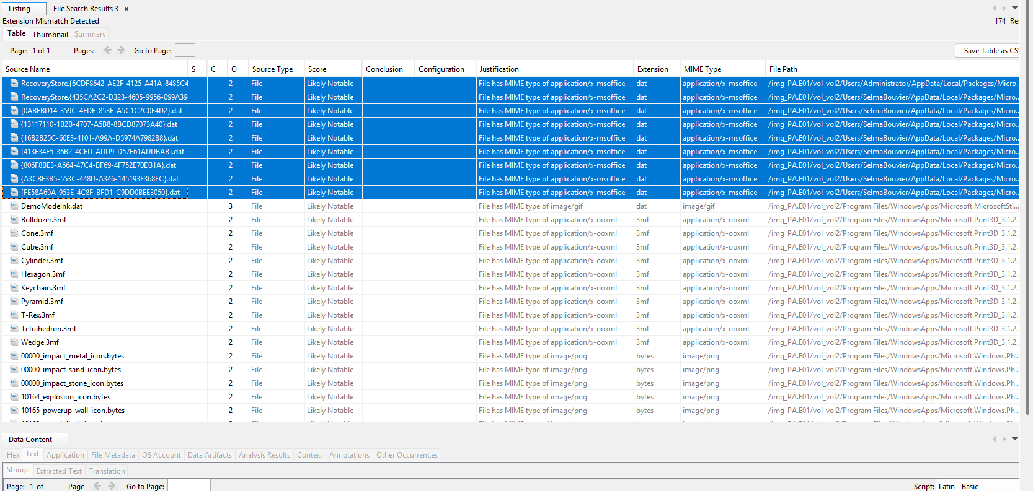
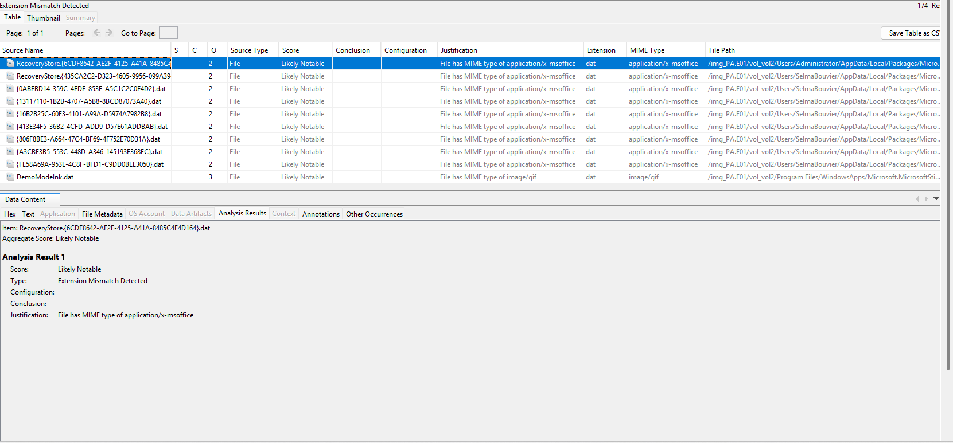

MFT Metadata Cross Check:
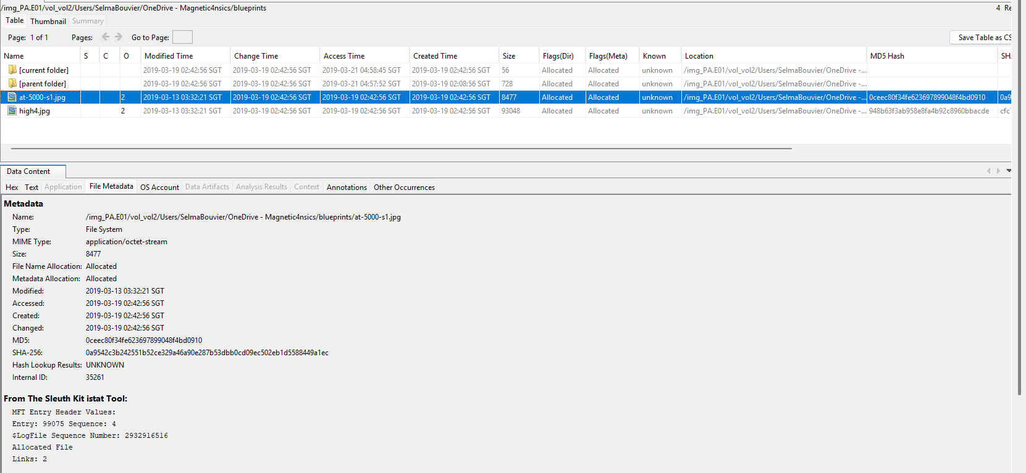

6.4 Internet and Application Usage
Using Web Artifacts and Recent Activity modules:
- Web browsing activity was identified
- Browser history and downloaded files were present
- Evidence of cloud storage usage was found
These artefacts suggest regular internet usage by the primary user.

Actions Taken:
- Browser Cache and Artifact Analysis: Analyzed the Browser directories (Microsoft Edge), which we are able identify traces of external cloud storage interactions within (\AppData\Local\Packages\Microsoft.MicrosoftEdge_8wekyb3d8bbwe\AC\)
- Corporate Cloud Tracing: Located a DOMStore XML file for magnetic4nsicscom-my.sharepoint.
- Private Cloud Evidence: Identified 9 Javascript cache files (mega-*.js) associated with mega.nz and able to recovery a MEGA-RECOVERYKEY for Selmabouvier
- Remote Access Identification: Conducted a search on Program Files (x86) for TeamViewer artifacts in user directories and identified a full installation inside the folder
- History Deletion Analysis: Examined the History.IE5 directory for evidence of any intentional concealment

Results:

- Unauthorized Cloud Exfiltration: With correlation to 19/03/2019 02:45:09 SGT, the DOMStore artifact confirms that there was access to the corporate SharePoint environment. This was followed by activity on mega.nz between 02:53 SGT and 03:00 SGT, during that a recovery key was downloaded, which gives the intent that a moving of data to a private account may be in play.
- Remote Access Staging: A full installation of TeamViewer was found in the Program Files and active on the system. Furthermore, the deleted TeamViewer folder and update.exe in Selmabouvier’s and Administrator’s Temp Directory respectively, proving and prompting attempts of wiping the remote session traces.
- Intentional Concealment: Selmabouvier systematically deleted the web history fragments for Microsoft Edge. For specifics, the folder MSHist01(20190307-20190308) was deleted on 15/03/2019, during the active session of activities between 13/03/2019 – 19/03/2019, to obsecure internet activities.

Web Artifacts
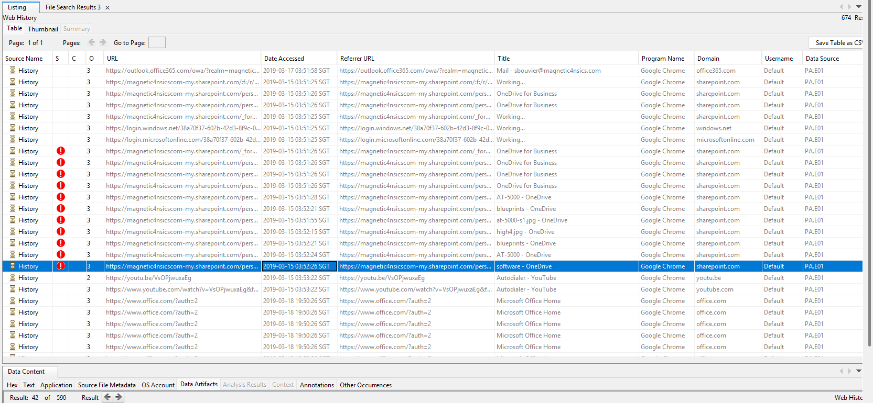
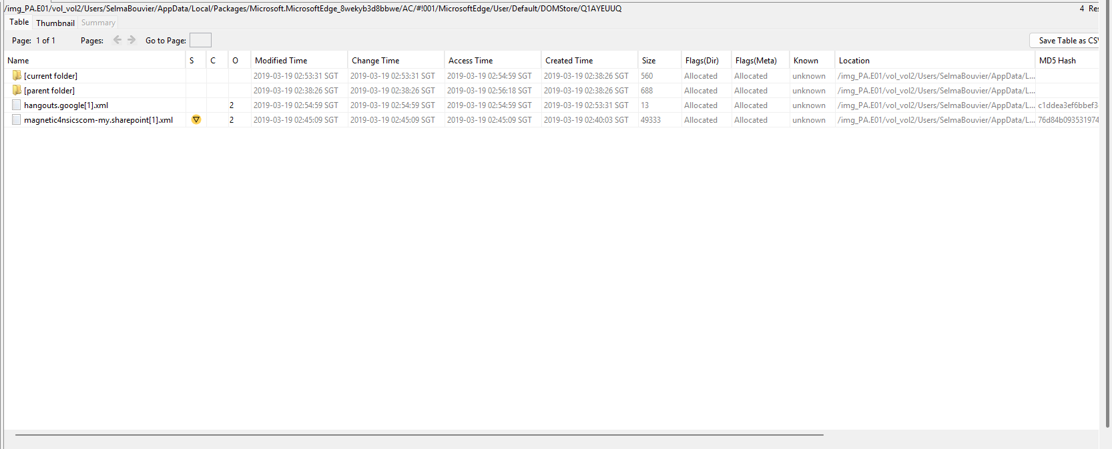
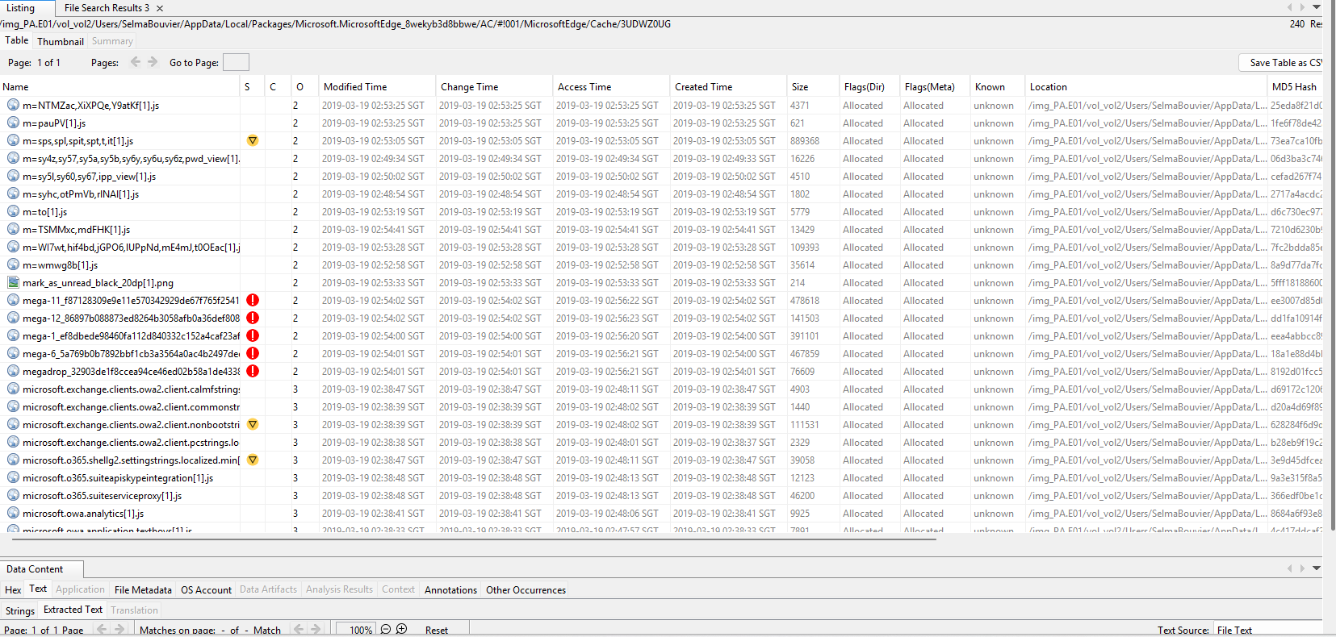

TeamViewer Remote Access:
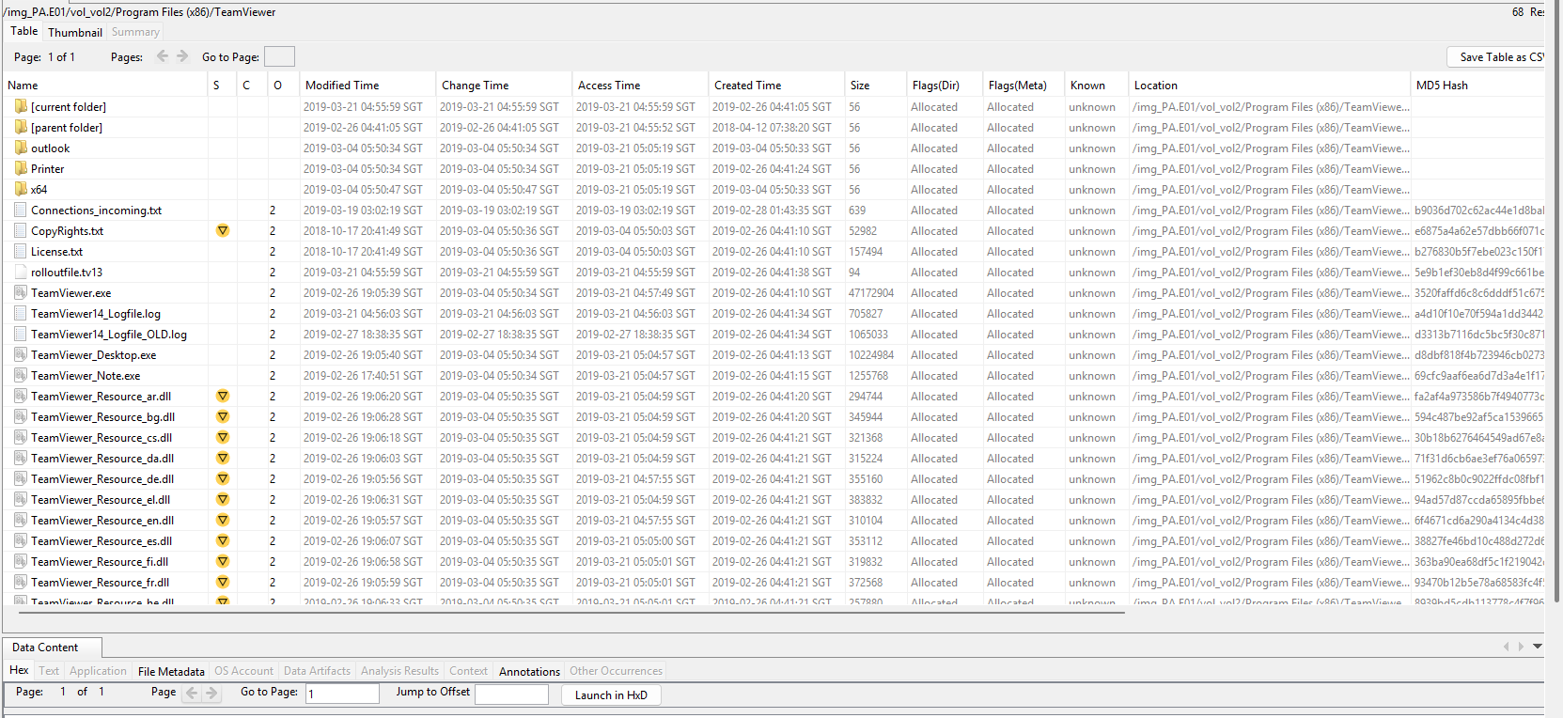
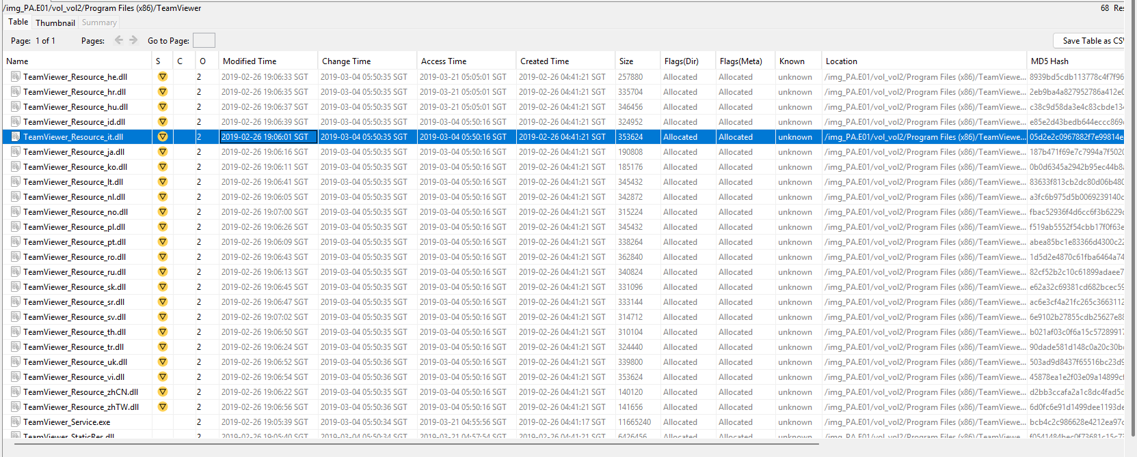
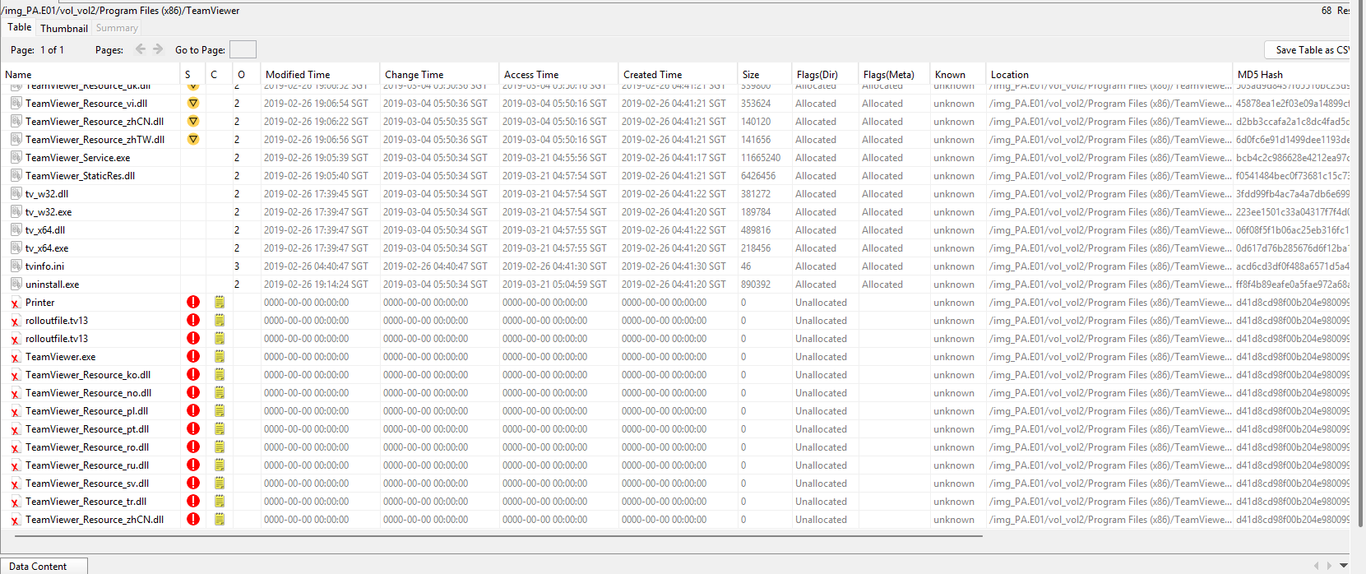

TeamViewer Deleted Trace (Administrator):
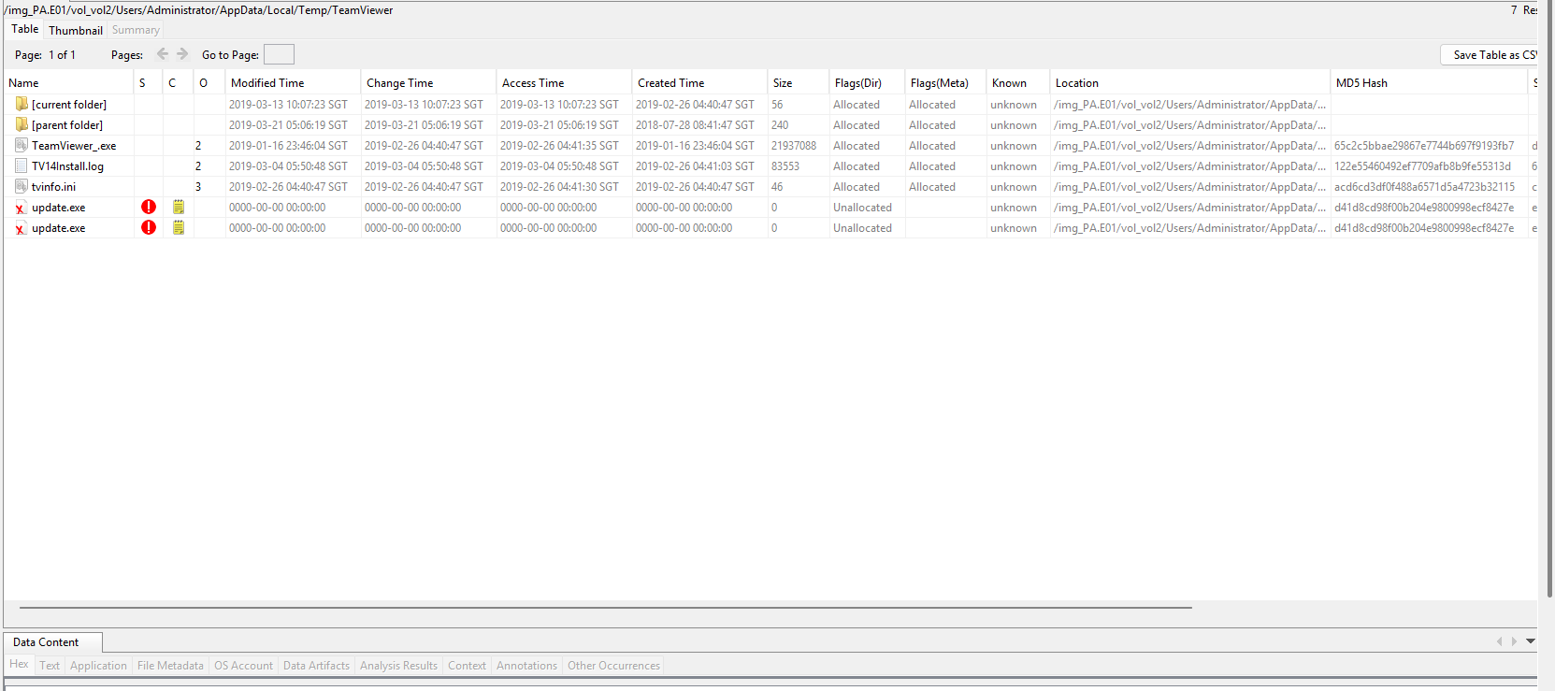

Deleted History folders (Concealment) and Relevant within active period:
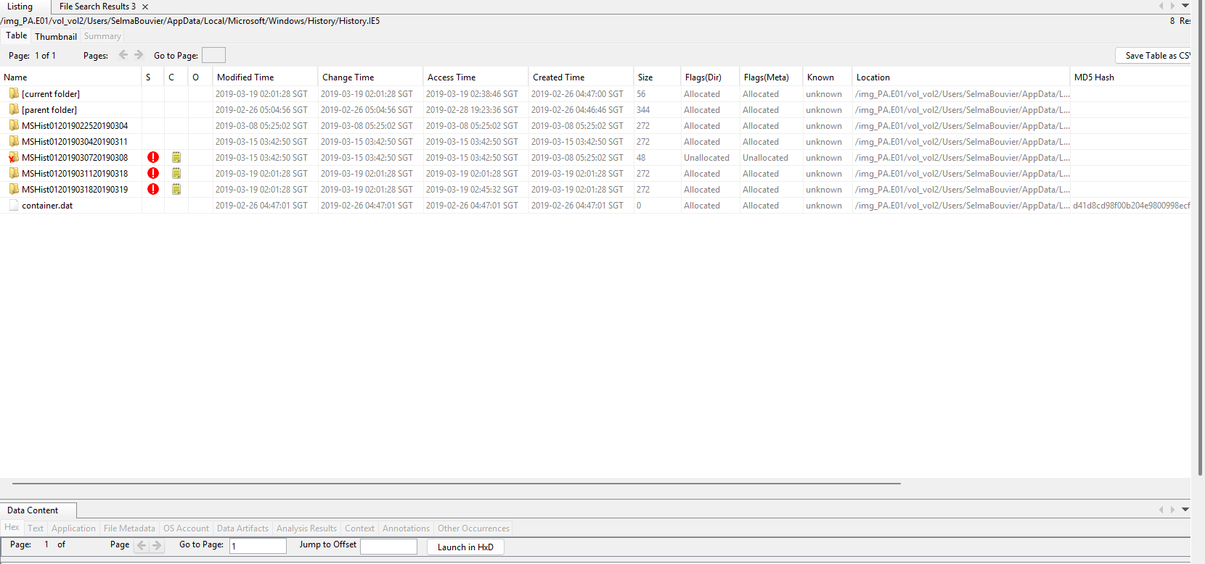

6.5 Timeline Analysis
Using Autopsy’s Timeline feature:
- User logins
- Program executions
- File access events
were correlated into a chronological sequence.
The timeline supports consistency between user activity and system usage patterns.

Actions Taken:
- Temporal Scoping: Defined the examination windows of the timeline analysis using by filtering start and end date to capture the full lifecycle of the incident (09/02/2019 – 20/03/2019)
- Interactive Filter Application: Applied filters to include text such as “Selmabouvier”, “Administrator”, or “vhd” to isolate both user-specific web and file activity as well as virtual hard disk that were created, modified, or accessed during the lifecycle of the incident of the system processes
- Event Correlation: Cross-references all Web history, Driver Activity, and any execution of administrative programs in order to identify any specific windows of exfiltration and concealment
- Visual Mapping: Using the timeline Details View to visualize the artifacts that were generated during the exfiltration on March 19th and the cleanup/concealment on March 20th.

Current Chronological Sequence of Key Events:

- 15/03/2019: First concealment. During an active session on Selmabouvier, deleted the MSHist012019030720190308 (07/03/2019 – 08/03/2019) history fragments to obscure any early internet activities during the date.
- 19/03/2019 (02:38 – 02:45 SGT): Data Access. During this date, the user was able to access to the corporate resources via Microsoft Edge, by logging on Outlook Web App (OWA) and the corporate SharePoint environment via the magnetic4nsicscom-my.sharepoint .
- 19/03/2019(02:53 – 02:54 SGT) Exfiltration. During this date, a large amount of MEGA.nz Javascript cache files was created, and a MEGA-RECOVERYKEY was downloaded, which helps mark the movement of corporate data to a private cloud account which is not known.
- 20/03/2019 (20:58 – 21:06 SGT): Remote Cleanup Initiation. The administrator account was seen downloading and installing TeamViewer, as well as the following up activation of the vhdmp.sys driver. This is called “Smoking Gun” which allows mounting and subsequent deletion of the SecretStuff.vhd staging container.
- 20/03//2019 (21:26 SGT): Forensic Wipe. The Administrator account at this time was shown to be accessing the FTK Imager Lite components on the desktop to finalize the removal of any forensic traces or tools that were used during the exfiltration.
Correlation Results:

The timeline establishes that the exfiltration occurred during Selmabouvier’s session on the 19th March 2019, while the Administrator account was later used to perform a systematic anti-forensic wipe of the staging area and remote access tools on the 20th March 2019. This proves that intentional concealment and a coordinated effort was used to hinder the post-incident investigation for any forensics investigator.

Filtering via Selmabouvier

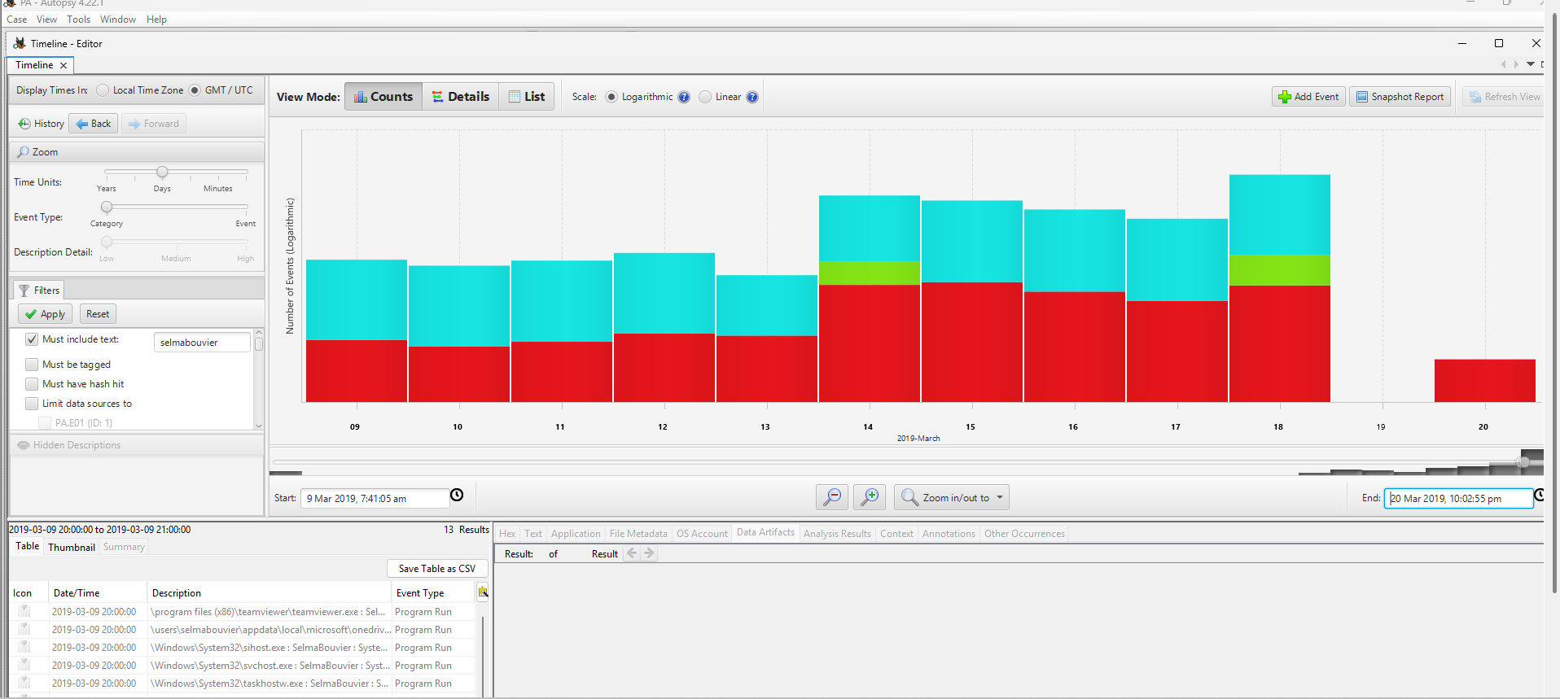

Filtering via Administrator

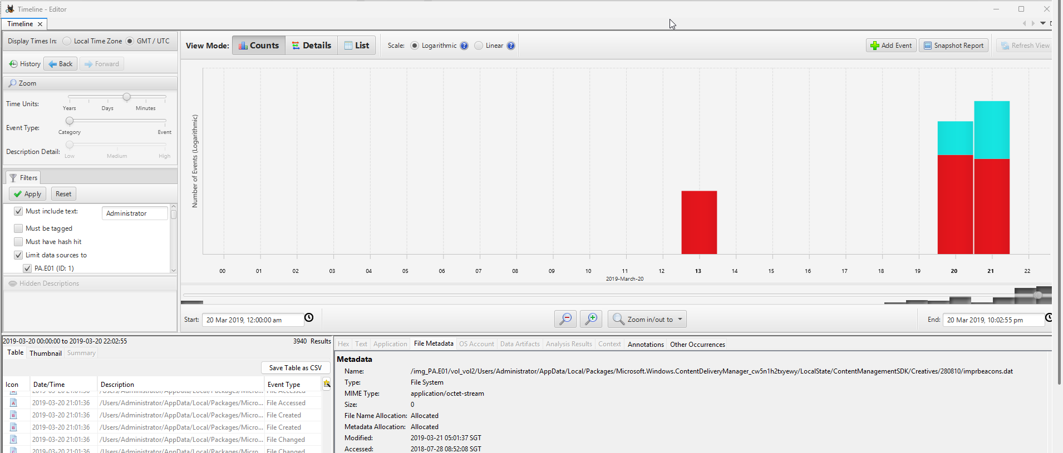

Filtering via Virtual Hard Disks
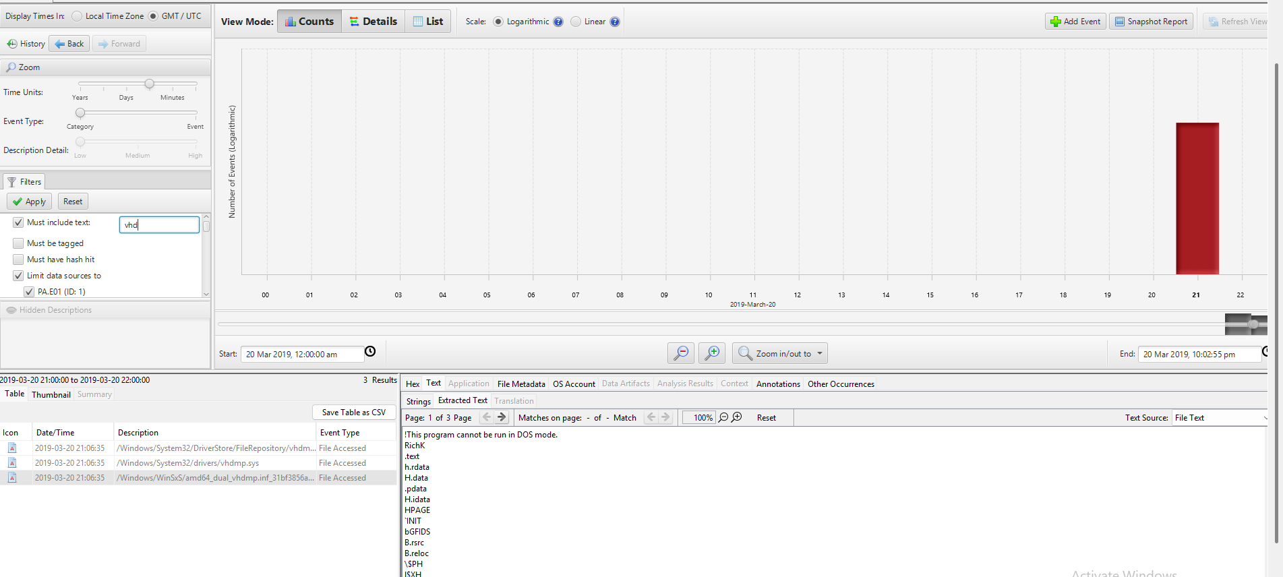

VHDMP
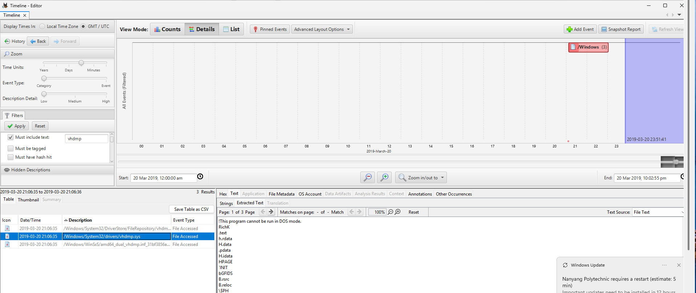

TeamViewer
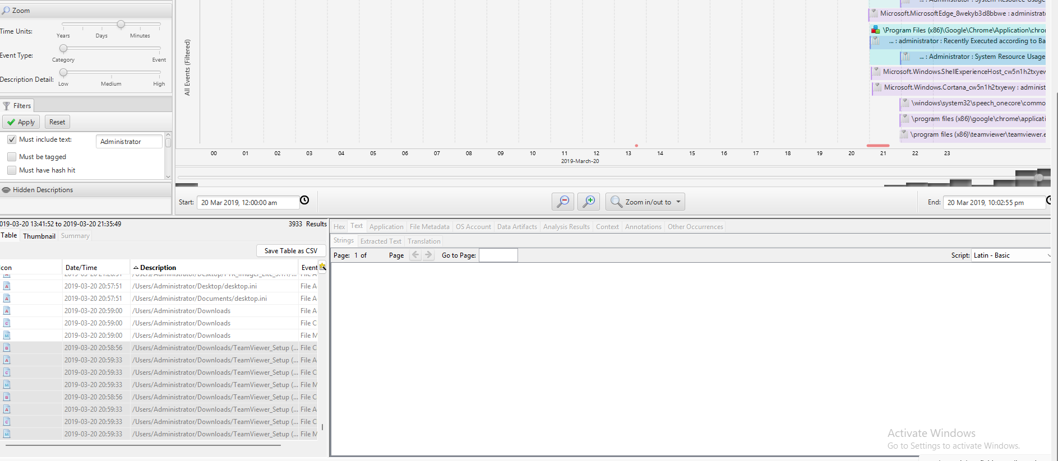
First FTK_Imager Lite 3.1.1 Accessed
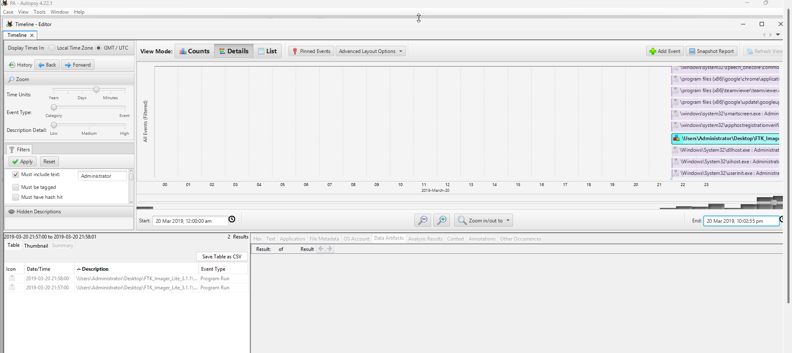

7. Interpretation of Findings
Based on the Autopsy analysis:
- Coordinated Data Exfiltration: The evidence above gives confirmation of a systematic exfiltration of intellectual property. With Selmabouvier account used to utilize to access sensitive blueprints via corporate SharePoint on 19/03/2019, which was then transferred to a private MEGA.nz account. Then MEGA-RECOVERYKEY was downloaded on the 02:54 SGT which strongly indicates the intent to secure and maintain access to this exfiltrated data on a private platform.
- Intentional Staging and Internal Concealment: The usage of (SecretStuff.vhd) Virtual Hard Disk on the desktop was served as a staging area to aggregate files for bulk movement while attempting to bypass the standard file system monitoring. Meanwhile, MSHist history fragments were systematically deleted on 15/03/2019 and the VHD container being removed on 20/03/2019 demonstrated a clear pattern of anti-forensic behavior intended to obscure the user’s trail of intention.
- Unauthorized Administrative Cleanup: The Administrator account was definitely linked towards the destruction/anti-forensic wipe of the evidence. Viewed via the timeline earlier showed installation of the TeamViewer at 20:58 SGT on 20/03/2019, followed by the immediate triggering of the vhdmp.sys driver at 21:06 SGT, which proves that the account was used for the mounting and dismantling of staging containers remotely. The FTK Imager Lite components execution time at 21:26 SGT further confirms the use of forensic tools to conduct a anti-forensic wipe of the system traces.
- External Media Vector: Metadata anomalies where the Created timestamp was more recent than the Modified timestamp on the blueprints (magnetic4nsics\ blueprints), confirms that these files were introduced to the system from an external source. Through the connection of the Adomax USB (Serial ID 42) matching the final cleanup window, identifies it as the likely physical vector for the removal of data and the introduction of any unauthorized tools unusually found.
- Document Interaction via Browser: Identified Microsoft edge recovery files with MS Office MIME types (within mismatching extensions of .dat), proving that the corporate Word and Excel documents were actively viewed and manipulated within the browser interface during the exfiltration period.

Do note that all interpretations are based of the chronological correlation of recovered digital artefacts and do not assume any user intention beyond what was evident within the recorded system actions.

8. Limitations
- Where .db files are unable to be accessed via SQL tools (DB Browser)
- Where some of the Internet history resources seem to have been wiped out

9. Conclusion
This forensic examination successfully identified users’ activities, program execution, file usage, and internet activities, and concluded that:
- Data Exfiltration: The user account Selmabouvier was the mainly involved in the exfiltration incident between 13/03/2019 – 19/03/2019. This account was used to access sensitive information via corporate SharePoint environments which were then staged within a container before being exfiltrated to a private cloud account on 19/03/2019 at 02:54 SGT. MEGA-RECOVERYKEY providing definitive evidence for the intent to maintain long-term private access to the data exfiltrated.
- Intentional Concealment and Cleanup: Significant anti-forensic measures were used to hinder the investigation. Action include deletion of web history fragments, dismantling of the staging container, and data carving executables from unallocated spaces that were used to prevent discovery.
- Administrative Account Misuse: The Administrator account was linked to the final clean up of forensics traces on 20/03/2019, where the timeline showed that the account was used to install TeamViewer at 20:58 SGT for remote access, and then triggered vhdmp.sys driver at 21:06 SGT to dismantle the VHD staging container. Finally, executed FTK Imager Lite 3.1.1 at 21:26 SGT, proving an unauthorized use of forensic software to wipe any usage of the exfiltration tools.
- External USB Confirmation: Metadata anomalies on the Magnetic4nsics blueprint files showed that the Created timestamp being more recent than the Modified timestamp provides that the files were either copied or moved from another location. The connection of AdoMax USB correlates with the final cleanup phase, identified as a primary vector for the movement of unauthorized data and tools.

10. Declaration of Generative AI Use
I declare that generative artificial intelligence tools were used in the preparation of this examination / case report.

The use of generative AI was limited to the following purposes:
- Improving grammar and academic writing style
- Assisting with report structure and formatting
- Clarifying general digital forensics concepts
- Constructing filtering codes for Windows Event Viewer
- Understanding how to externally open files/features within applications

All forensic analysis, evidence identification, interpretation of artefacts, screenshots, timelines, and conclusions were conducted by me using the Autopsy forensic tool.
No generative AI tool was used to analyze the forensic image or to generate findings.

